Identifying Emotional States from Touch Gestures
Samit Bhattacharya  Computer Science and Engineering Department  Indian Institute of Science Ghuwathi Assam  E-mail: | Chandirasegaran Punithavel  Computer Science and Engineering Department  National Institute of Technology Puducherry - Karaikal  E-mail: chandrunitpy@gmail.com | Divyanshu  Computer Science and Engineering Department  Guru Nanak Dev University Regional Campus Sathiala  E-mail: divyanshu17x@gmail.com

Abstract— To date mostly everyone uses smartphone and as this trend is increasing, the next billion users are predicted to be of smartphones. Our research is to find user’s emotional state from their interaction with the smartphones, without using any extra hardware, in a cost effective way. The main idea relies on the fact that user interaction is more when they are in high arousal level and the interaction is minimal when they are in low arousal level. We have proposed a model to measure the arousal level from their 2-D screen gestures and categorize the emotional states based on their activity value. Then concluding result will be based upon comparison between activity values in time intervals.
Keywords—emotion, affective computing, mobile interaction, game play, touch.

Introduction
Human-Computer Interaction (HCI) is the study of how people interact with computer and to what extent computers are developed or not developed for successful interaction with human beings. Success is not a constant thing, it grows once we have achieved one. Likewise in HCI, its initial success is to provide better interaction of machine to human and now we are interested to make machine analyze human emotions and provide better interaction to human by itself. Before making machine to understand human emotion, let’s see how human understand emotions. Human emotions are conveyed to other person either verbally or non-verbally. From gentle touch to harsh sound, every action of human conveys some emotion. Are Emotions which are conveyed verbally can they be conveyed non-verbally? If someone says no then we are going to argue about how speech impaired people conveys their emotions. This clearly tells us emotions can be derived from human facial expression, speech, touch and body gestures. So what is an emotion? Emotion is the change in the states of organic subsystems in response to stimulus, as relevant to major concerns of the organism [2]. Are machines need to know all these emotions? It depends on the purpose of the machine, what degree of emotions they need to understand. Here, we are going to consider touch screen devices like smartphone, tablet, notepad, TV, etc. We are interested in finding emotions from touch.

Related work and Literature
There are lots of research that concentrate on affective computing using various methods such as: touch screen interactions processing, facial expression recognition, voice recognition, Natural Language Processing, gesture recognition, EEG signal processing, etc. Among these methods the cheapest way to find emotional state is from touch screen interaction. No extra hardware is required and it fits into day to day interaction lifestyle of all touch screen devices. The research paper “Don’t get Emotional”[] says that “conceptualize emotion as a waypoint rather than as a destination” i.e. our motto is to give better interaction rather than finding exact emotion. This is considered firmly in our research. While using touch screen device like smartphone, user may get excited, frustrated, bored or relaxed, these emotions are mentioned since these each emotion lies in each quadrant of Valence Arousal model, so these are the emotions the touch screen device may need to understand, to provide better interaction. User won’t reach certain emotion state all of a sudden, emotions are linked like a chain, to get excited they first will be in calm, relaxed, satisfied, content, glad ,pleased, happy, delighted and then excited. And it grows after that to astonish and aroused. So the emotions which needs to be considered and how they can be derived from the touch interaction are explained in this research.

Input Features
In general all touch device have some features which are common to it. All the touch device screens are flat and the interaction performed on all touch devices are same. For example to select a button clicked by user, to move to next page while a user scrolls or swipes. The interaction with these devices are classified into 2-D gestures and 3-D motion gestures. 2-D gesture are the gestures which are directly making contact on the 2-D screen. 3-D motion gestures are the gestures which change the value of various sensors in the device. Though 3-D motion gestures are not direct touch gestures on the screen, they can tell us about the contextual information about the user handling the device.
The 3-D motion sensors which are available in most of the touch devices like smartphones are:
- Proximity sensor
- Accelerometer sensor
- Light sensor
Accelerometer sensor tells about the user’s motion whether he is running or walking. Light sensor tells about the light intensity around the user. These are the additional factors which can support in deriving the emotional state of the user. The main input features are 2-D gestures and they are:
- Click
- Long Click
- Swipe
- Scroll
- Patting
These actions performed on the touch devices have common properties and they are
- Size
- Velocity
- Pressure
Size property gives the number of pixels covered by touch, Pressure property gives the pressure applied on the touch screen and the velocity property gives the velocity of the touch during swipe or scroll at a particular time. Velocity is the rate of change of size covered per unit time in a particular direction. Hence, it is directly proportional to the size. Finding pressure on the touch screen is hardware dependent and in most of the devices it just give static value either 0 or 1. By this value we can’t predict the exact pressure applied during touch interaction on the screen. By taking the analogy that more pressure covers more pixel size on the screen i.e. if user apply more pressure on the flat screen their fingers flattens out and it covers more size on the screen, we can say pressure is directly proportional to size. So we can conclude that size and time is the atomic property from which other properties are derived. So the size covered on the screen during touch interaction in a particular time is more sufficient to analyze the user’s interaction on the touch devices. Touch devices have certain APIs provided by their operating system to find the gestures and its size covered during touch interaction, for example smartphones running on Android provide APIs like GestureDetector and MotionEvent classes for sensing different gestures and measuring there size properties.

Proposed Approach

To analyze user’s emotional state we are using Geneva Emotional Wheel (GEW) [14] and partitioning the GEW into four quadrant - High Positive State, High Negative State, Low Negative State and Low Positive State as shown in Fig.1.

Discrete vs. Continuous Model
In Discrete model only 6 basic emotional states are considered for evaluation while in Continuous model we need to consider emotional states among dimensions. For example in Valence Arousal Dimensional model, every emotional state has two variables associated with it, namely Valence which means the positive or negative value of an emotional state, while Arousal means the degree of reactiveness to the stimuli. In Discrete model the estimation rate of final result is much more correct than Continuous model because in latter infinite pairs of co-ordinate points can be plotted which can lead to ambiguity in judgment. For example, Fear and Anger have same Arousal value. The guessing probability is less in Discrete Model and the results are more accurate. So, we will be adopting Discrete Model for evaluating Emotional States.

Categorizing behavior similarities for modeling:
In discrete model the six basic emotions are much more expressible using the natural language. These basic emotions are immutable throughout the evolutionary process.
The language based categorization corresponds to unique response pattern. In continuous model, different emotions having same value in a particular dimension are indistinguishable. So to create a set of emotions on the basics of behavior similarities language based basic categorization should be used.
The Emotional States are classified into four major categories based on their arousal level and their valence. Their naming follows the convention AB state where A represents the Arousal Level and B represents the Valence level. They are:
- High Positive State
- High Negative State
- Low Negative State
- Low Positive State
This abstract classification as shown in TABLE 1 by mapping emotional states can prove useful for both similar behavioral application response and developing mobile gestures conclusions for emotional states.

- Abstract Emotional State
POSITIVE valence |  | NEGATIVE valence
HIGH POSITIVE | LOW  POSITIVE | HIGH NEGATIVE | LOW  NEGATIVE
EXCITED | RELAXED | FRUSTRATED | BOREDOM

Arousal Level / Power level
In High Arousal State more pressure is applied on the screen[8] due to high interaction level or interaction rate . Pressure can be calculated using the Android API, in class Motion Event’s touchEvent.getPressure() which returns float value from 0 to 1. Since it is hardware dependent, its value changes for different devices and mostly it returns either 0 or 1. If we apply more Pressure fingers flattens out and cover more size. Hence the size covered tells indirectly about the pressure applied. Instead of calculating the Pressure applied on the screen, the pixel size covered by the finger for each touch is calculated using the touchEvent.getSize() and size can be calculated on mostly all touch screen based phones , instead of pressure .
Pressure applied on the screen is directly proportional to the total pixel touched by the user and this is the relation used by
most of the cellphone vendors to provide pressure information from touch gesture’s size[6].
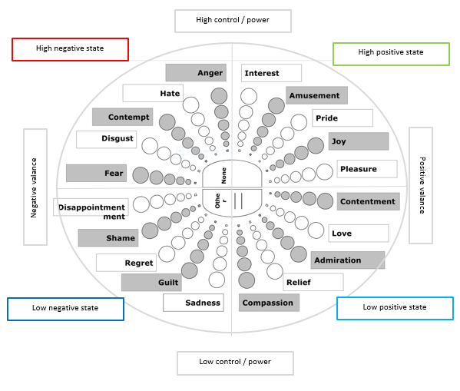
Fig.1 Partitioning Geneva Emotional Wheel (GEW) into four States
For interval of 3 seconds each, users touch size for each event is obtained and its total size of interaction is calculated which gives the Activity Value for that particular interval. Higher the Activity Value (AV) higher the arousal level and vice versa. By comparing the Activity Value (AV) of the current interval with its previous interval, the valence level is obtained. The trend in Activity Values with time is also observed to make emotional state prediction more concrete.
Activity Value (AV) = Total size of touch interaction by the user in a particular interval (3sec).

Valence Level
Each Activity Value (AV) directly gives the arousal level of the activity but to find the valence level of the current interval its Activity Value (AV) is compared with its previous interval. The following hypothesis maps the cumulative Arousal and Valence combination in quadrants, as shown in Fig. 1.
Our hypothesis:
- High Negative State decreases the user’s interaction and the Activity Value fluctuates in the continuous interval, with high peaks of AV in time interval. For example the frustration will be with more clicks, swipes and scrolls.
- High Positive State increases the user’s interaction and the user maintains that AV .For example Excitation while typing or scrolling while reading.
- Low Negative State mostly follows the High Negative State(s) and the AV decreases monotonically or has some low AV peaks. Like boredom after frustration.
- Low Positive State mostly follows the High Positive State(s) and maintains the low AV peaks during intervals. E.g. relaxed state.

Implementation

Trending Data Collection Methods
- Questionnaires - Given a source as a stimulus, subject’s emotional states is recorded in questionnaires and scaling is done based on its degree.
- Performing Gestures - Given an emotion state, subjects are asked to perform gestures for that.
- Applications - Applications recording day to day gesture activity is created and tested with the subjects.

Creating applications is more reasonable so in our implementation we created an application to collect user’s touch data.
The data to test above proposed hypothesis is calculated by creating a game application “HackEmo” as shown in Fig.2, played on an android smartphone. The game is available on GitHub, link: HackEmo. It is a guessing game created to record user’s info, name, age and gender and touch interaction. In this game a number will be displayed which a user has to guess, which is placed in 5 buckets randomly between buckets A- E. The game duration is 60 seconds and the users were instructed to get maximum score as possible. The users were instructed to be cautious about a penalty of -1 for each wrong answer.
The game play is as follows:
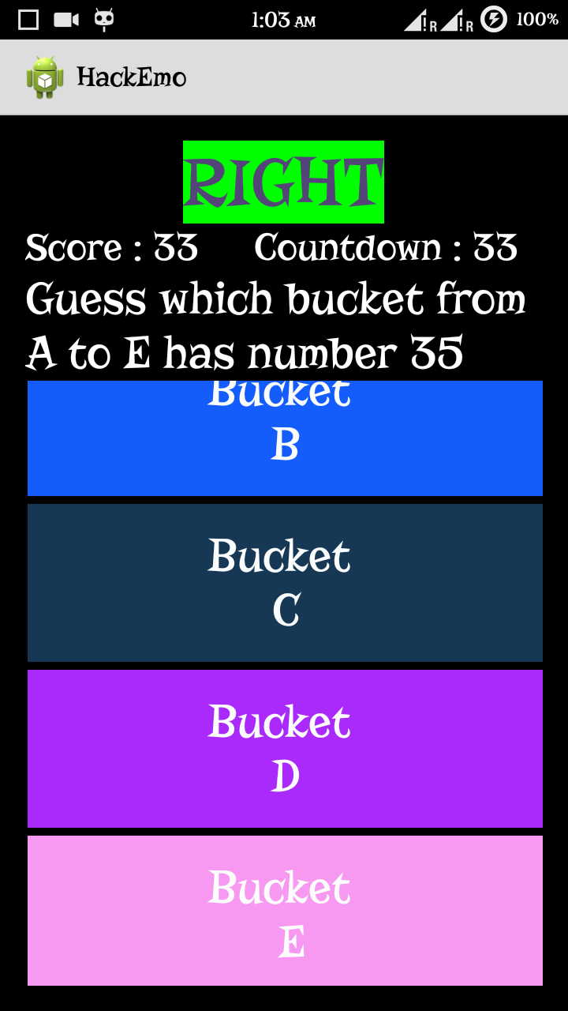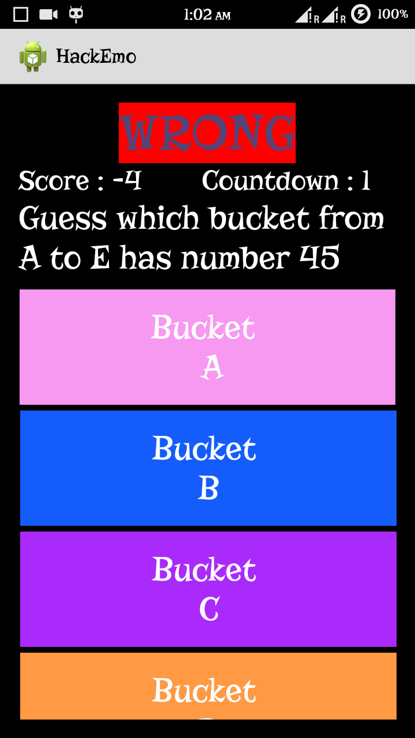
Fig.2 Guessing Game View to analyze valence level
Code | Mode | Time interval (sec)
2 | Random | 0-15 & 31-45
0,1 | Losing, Winning | 16-30, 46-60

The Mode Winning and Losing will be randomly selected for specified time intervals each time and user is not told about these Modes.User’s emotional state is to always guess the right bucket every time.
Only the active time intervals were taken into consideration, i.e. when the subject was actually interacting with game continuously. In Winning mode, the user always win and in losing mode, the user always lose. The subjects were given two attempts, in the first attempt since the gameplay is new they were playing the game in low arousal level and in the second attempt their arousal level increased much to get more score. By giving two attempts, we can see the change in their arousal level.
Winning makes user excited and losing makes them frustrated. In continuous losing part of the game, the users negative valence level is analyzed and in the continuous winning part of the game, users positive valence level is analyzed.
User’s activity is recorded throughout the game and their touch size is calculated and the Activity Value (AV) for each 3-seconds interval is calculated and plotted in a graphs shown in Fig 3.a,3.b where in Y-axis, each unit represents the Activity Value (AV) and in X-axis, each unit represents the an interval of 3 seconds.

RESULT
After collecting data from subjects, the graph is analyzed during their winning part and their losing part. in both Low Arousal (Fig.3.a) and High Arousal Mode (Fig.3.b). The Emotional state and Game Mode is plotted, after generating graph, along the time intervals.
FOLLOWING RESULTS ARE DERIVED FOR EACH STATE:
- Low positive: Low Activity Value (AV) peaks are visible
- Low negative: The Activity Value (AV) atrophies to minimum value.
- High positive: The high Activity Value (AV) is maintained throughout interval
- High negative: High Activity Value (AV) peaks are visible in interaction interval.
The AV with Time and the data from graph obtained is observed. Following results are obtained:
- Mapping AV and Emotional State
Arousal Level | Average AV | Maximum, Minimum
High Arousal | 4.23 | 6.5 , 2.83
Low Arousal | 0.94 | 2.1,0
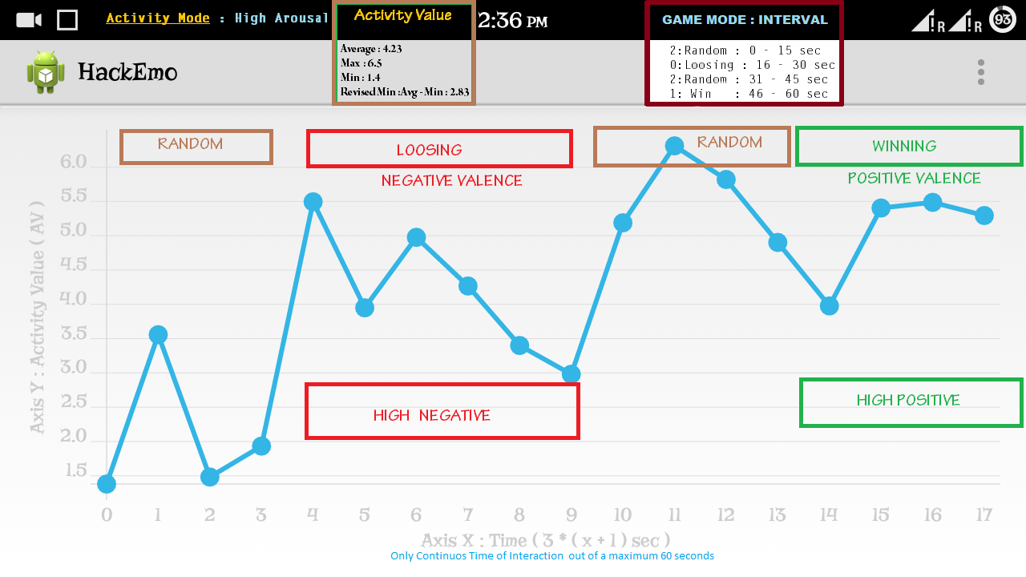

Fig.3.b Graph showing Valence level in High Arousal mode
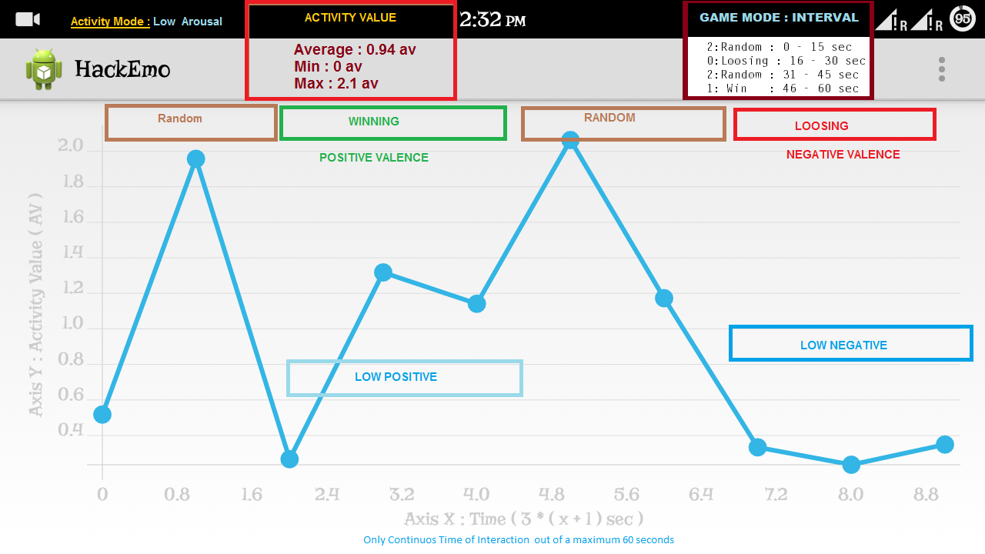

Fig.3.b Graph showing Valence level in Low Arousal mode

Conclusions And Future work
This research work was ours contribution to human computer interaction. Since touch screen is going to be a part of every future device for human computer interaction, accessing emotional state from touch gestures will enhance overall interface and application development. We conclude that it is possible to efficiently analyze emotional state using touch gestures and it is the less costly way. Our future work will be to test ours result on a much broader scale. The following research will dedicated to additional data collection for producing detection algorithm, learning process and applications.

References

- Kaveh Bakhtiyari, Hafizah Husain ,”Fuzzy model of dominance emotions in affective computing”, Neural omputing and Applications, 2014-11-01.
- Klaus R. Scherer,” What are emotions? And how can they be measured?”, Social Science Information, December 2005, vol. 44 no. 4 695-729.
- Emotion Recognition through Multiple Modalities: Face, Body Gesture, Speech, Book Title: Affect and Emotion in Human-Computer Interaction, Book Subtitle: From Theory to Applications, pp 92-103
- Emotional Experience and Interaction Design, Book Title: Affect and Emotion in Human-Computer Interaction, Book Subtitle: From Theory to Applications, pp 116-129.
- William Sims Bainbridge, ”Computational Affective Sociology”, Book Title: Affect and Emotion in Human-Computer Interaction, Book Subtitle: From Theory to Applications, pp 23-34.
- Antje Lichtenstein, Astrid Oehme, Stefan Kupschick, and Thomas Jurgensohn, ”Comparing Two Emotion Models for Deriving Affective States from Physiological Data”, Book Title: Affect and Emotion in Human-Computer Interaction, Book Subtitle: From Theory to Applications, pp 35-50.
- Leijdekkers, P. , Gay, V., Wong, F., “CaptureMyEmotion: A mobile app to improve emotion learning for autistic children using sensors”, Computer-Based Medical Systems (CBMS), 2013 IEEE 26th International Symposium on 20-22 June 2013, pp:381 - 384 .
- Yuan Gao, Nadia Bianchi-Berthouze, Hongying Meng, ”What Does Touch Tell Us about Emotions in Touchscreen-Based Gameplay?”, ACM Transactions on Computer-Human Interaction (TOCHI) TOCHI Homepage archive, Volume 19 Issue 4, December 2012, http://dl.acm.org/citation.cfm?id=2395138.
- Céline Coutrix CNRS, Laboratoire d'Informatique de, Grenoble Nadine Mandran CNRS, Laboratoire d'Informatique de, Grenoble, “Identifying emotions expressed by mobile users through 2D surface and 3D motion gestures”, UbiComp '12 Proceedings of the 2012 ACM Conference on Ubiquitous Computing, pp: 311-320.
- Designing gestures for affective input: an analysis of shape, effort and valence, Item Type: Conference or Workshop Item (Paper), ID Code: 145, Deposited By: Interaction Researcher, Deposited On: 07 Sep 2009, Last Modified:18 Nov 2009 15:54
- Touch communicates distinct emotions. Hertenstein, Matthew J.; Keltner, Dacher; App, Betsy; Bulleit, Brittany A.; Jaskolka, Ariane R., Emotion, Vol 6(3), Aug 2006, 528-533. http://dx.doi.org/10.1037/1528-3542.6.3.528
- Wikipedia: https://en.wikipedia.org/?title=Affective_computing
- Leysia Palen and Susanne Bodker, ”Don’t Get Emotional”, Book Title: Affect and Emotion in Human-Computer Interaction, Book Subtitle: From Theory to Applications, pp 12-22.
- Sacharin,V., Schlegel, K., Scherer, K.R., “Geneva Emotion Wheel Rating Study”, unpublished.

